Introduction to the Four Fields Mark 4: 26-29

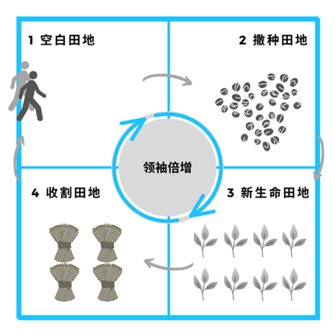介绍神国增长的四田地《马可福音》 4:26-29

##### **Trainer’s Outline** 培训者大纲

1. INTRODUCTORY QUESTIONS 介绍的问题
2. SMALL GROUP STUDY OF MARK 4:26-29 小组学习《马可福音》4:26-29
3. AN OVERVIEW OF THE FOUR FIELDS 神国增长的四田地
   1. FIELD ONE: THE EMPTY FIELD 田地1 – 空白田地
   2. FIELD TWO: THE SEEDED FIELD 田地 2 – 撒种田地
   3. FIELD THREE: THE GROWING FIELD田地 3 – 新生命田地
   4. FIELD FOUR: THE HARVEST FIELD 田地 4 – 收割田地
   5. LEADERSHIP MULTIPLICATION领袖倍增
4. CONCLUSION 总结

# Introduction Questions 介绍的问题

“Does anyone here have experience as a farmer? As a farmer, what is the process of growing crops? What does a farmer have to do to grow crops?”

“有人种过田吗？”

分组讨论：庄稼的生长有什么过程？农夫需要怎么做才能使农作物生长？

As a group, discuss the steps a farmer might take. He finds a piece of land. He clears the land. He sows seeds and waters them. Finally, when the time he right, he harvests his crop and gathers it together.

培训者确保答案包括：1找土地；2清理土地；3 播种浇灌；4收割与再种。

As church planters and church planting catalysts, our primary task is to partner with the Holy Spirit in bringing the Kingdom of God to the places where we work.

作为教会植立者和教会植立催化剂，我们的首要任务是与圣灵合作，使神的国度彰显

# Small-Group Study of Mark 4:26-29 小组学习《马可福音》4:26-29

Let’s look at the passage together. In Mark 4:26-29, Jesus shares a parable using the example of a farmer to illustrate the growth process of the kingdom of God. This passage is often referred to as “Four Fields” although in reality a more accurate description would one field with four stages of development or growth. Given that this passage is a parable or metaphor, not an instruction manual with precise steps, we are going to use it as a model for kingdom growth, but its not necessarily as a step-by-step guide for church planting.

让我们一起看马可福音4: 26-29。耶稣以种子成长收割的比喻，说明了神的国度。

Divide the trainees into groups of 2-3. Give them 5-7 minutes to read the passage and identify the steps the farmer takes in Jesus’ parable.

将受训者分成2-3人一组。培训者启发他们思想农夫种田的整个过程。给他们5到7分钟时间一起讨论，并列出种田所须采取的各项步骤。

While the trainees are doing this, the trainer should draw the following image on a white board or similar tool, which the trainer will fill out briefly during this session and more throughout the week.

当受训者进行分组讨论时，培训者应在白板上绘制以下图像。培训者在本次培训中将简单地填入相关内容。

（建议：培训者带领受训者将分组讨论的结果综合归纳成五个部分后，才在白板绘制以下图像，并将相关内容简单填入图像中。）

# An Overview of the Four Fields 神国增长的四田地

## Field 1: The Empty Field 田地1 – 空白田地

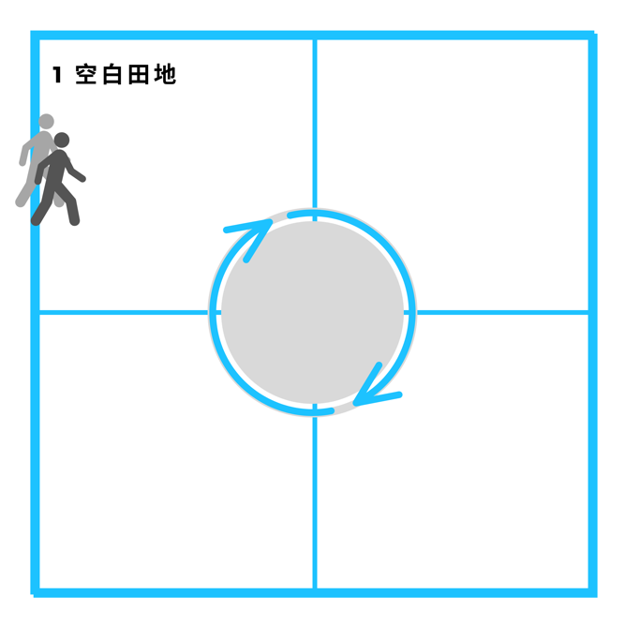When a farmer first decides to farm a piece of land, what is the first thing he must do? Enter the field!

当农夫决定耕种土地时，他必须做的第一件事是什么？进入那地！

Key Question(s) – In church planting, how does one enter a new field?

关键问题：在教会植立中，我们如何进入新田地？

Where do we start? How do we know when and where to sow seeds? As outsiders attempting to enter a new place and cross cultures with the gospel these questions demand consideration lest the church planter spoil the potential harvest through hasty or ill-advised action.

我们从哪里开始？我们如何知道该何时及该在哪植立教会？当我们身为外人试图将福音以跨文化形式带进一个新地方时，我们需要考虑避免因仓促或不明智的行动破坏了教会的植立。

Understanding the biblical answers to such questions provides the church planter with a simple, clear strategy for transitioning from an outsider driven method to an insider movement. This is our entry strategy.

对于些问题的答案，圣经向教会植立者提供了简单和清晰的本土化策略。这是我们的进入策略。

## Field 2 : The Seeded Field 田地 2 – 撒种田地

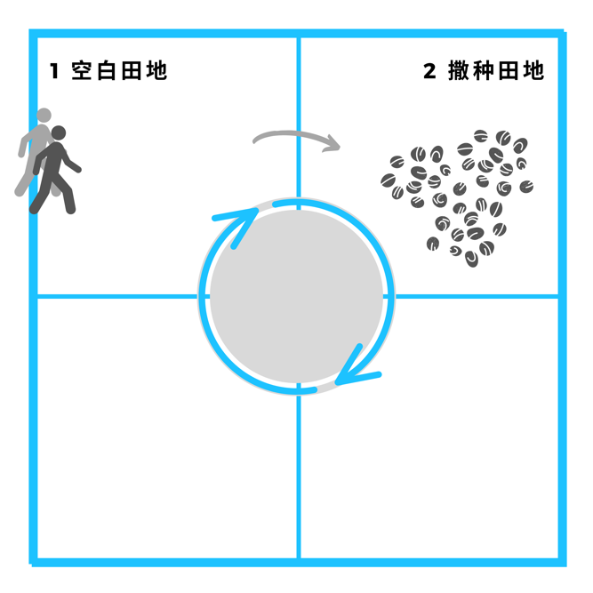After entering an empty field, what is next step in the farming process? Sow Seed. In our context, what is the seed? The Gospel.

进入空白田地后，耕种过程的下一步是什么？撒种。在教会植立中，种子是指什么？福音。

Within the second field the church planter is faced with a simple question. Key Question - What do I say? 在田地2中，教会植立者面临一个关键问题：我该说什么？

Answering this question seems simple, but the need to present the gospel across ethnic and social barriers is anything but simple. Understanding worldview, apologetics, and the essential elements of the gospel are all a part of answering this key question. A proper understanding of field #2 will provide the church planter with reproducible and effective tools for sharing the gospel.

回答这个问题似乎很简单，但如何将福音在跨民族和跨社群障碍中表达出来并非易事。理解世界观，文化信仰诠释和福音的基本要素都是回答这个关键问题的重要部分。对田地2的正确理解将为教会植立者提供可复制且有效的福音传讲。

## Field 3: The Growing Field 田地 3 – 新生命田地

After the seed has been sown, in this stage of the process, the church planter begins to see the fruit of his labors. As the crop begins to emerge from the seeded soil, the farmer is faced with this question.

撒种后，在此阶段，教会植立者开始看到他的工作成果。随着种子开始从土壤发芽，农夫将面临一个新的问题。

Key Question: How do I make disciples?

关键问题：我该如何培育门徒？

Said another way, how do I promote growth? How do I make healthy disciples that will reproduce? The beginning stages of growth are critical as they determine the future success of the crop. The crop is at no point more vulnerable.

换句话说，我该如何促进成长？我该如何使健康的门徒将来能够繁殖？

由于此阶段庄稼最为脆弱，为了使它们将来能丰收，如何照顾它们生长的开始阶段至关重要。

For this reason, care must be given to present a purely biblical foundation on which future growth can be built. When we discuss this field more, we will discuss two main components in helping new disciples grow – the discipleship training process and biblical content.

因此，为了将来的成长，我们必须谨慎提供正确的圣经根基为基础往后我们将进一步讨论帮助门徒成长的两个主要内容：门徒培育的方法和圣经根基的内容。

## Field 4: The Harvest Field 田地 4 – 收割田地

This stage of field represents the time harvest. As the harvest is cut and bundled the church planter faces the following question.

Reproducible Entry Strategy可复制的进入策略

此阶段的田地代表收割的时间。随着收割，教会的植立者会面临以下问题。

Key Question – How do I form churches?

关键问题：如何组建教会？

Answering this question properly will ensure the long-term growth, health, and reproduction of new churches. We will discuss how to transition from groups of disciples to churches, and also topics such as who can baptize and lead the Lord’s Supper. The Bible has a large amount of material devoted to answering this question through both example and direct command. We will refer to this field as “Church Formation.”

正确回答此问题将确保新教会长期的健康成长和繁殖。我们将讨论从一群门徒转化到一个教会，包括谁可以给人施洗并主领圣餐。圣经中有大量的榜样和直接的命令可以回答这个问题。我们将把这个阶段称为“教会的形成”。

## Leadership Multiplication 领袖倍增

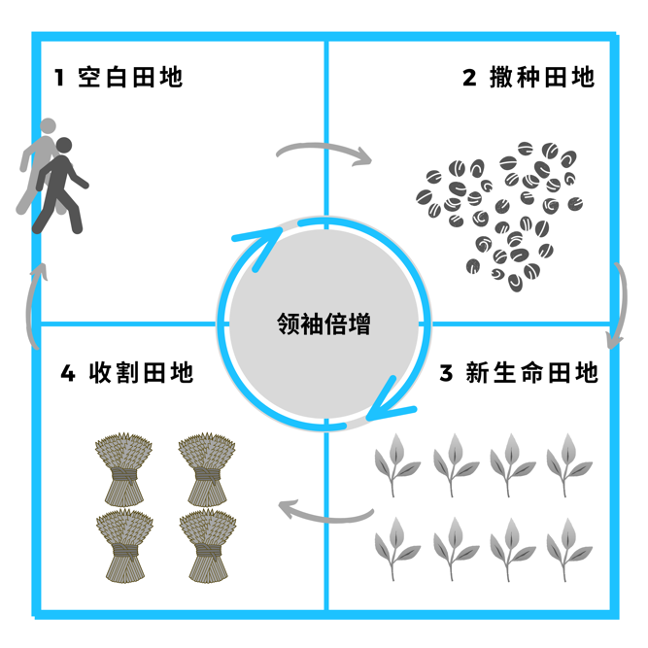Finally, the process repeats itself. As leaders emerge from the disciples and churches in our target group, we must ask the following question.

最终，上述整个过程会继续重复。当我们的门徒和教会中浮现出领袖时，我们必须提出以下问题。

Key Question – How do I develop and multiply leaders?

关键问题：我们如何发展和倍增领袖？

Answering this question properly ensures a sustainable and multiplied harvest. When leaders are multiplied, movements begin resulting in generations of disciples, churches, and leaders. We will refer to this process as “Leadership Multiplication”.

正确回答此问题将确保可持续及倍增的丰收。当领袖倍增时，将带来门徒、教会和领袖代代相传的运动。我们将把这个阶段称为“领袖倍增”。

# Conclusion 总结

In Mark 4:26-29, Jesus uses this paradigm to explain how the Kingdom of God grows, and as such, we will use this kingdom growth paradigm as an outline for how we as church planters can bring the Kingdom of God to the areas where we work. During this training, we will use these phases (plus leadership development) to outline the church planting process.

在马可福音4:26-29，耶稣用此比喻来述说神国度的成长。因此，我们将思考作为教会的植立者如何与神同工使神的国度在我们工作的地区显明出来。我们在本培训中，会继续使用以上神国增长的五个步骤来概述开荒植立教会的过程。

There’s one final thing, we haven’t discussed from this parable. In the passage, how does the seed begin to sprout?

最后还有一件事，我们还没有从比喻中讨论：种子是如何发芽渐长的？

In verse 27, we learn there is an element that seems to be outside of the farmers doing. In the same way, while we, like the farmer take intentional, active steps to produce a harvest, there’s also a supernatural element that is out of our control. The Holy Spirit must work in the life of the believers, we serve. As such, we as “farmers” partner with the Holy Spirit to bring “growth” in the areas where we work.

在第27-28节，我们看到有一个在农夫工作之外的因素。同样，尽管我们像农夫一样刻意采取积极的步骤来期待产生丰收，但有一个超自然的因素：圣灵 —— 我们必须与祂一起工作。 因此，我们作为“农夫”是与圣灵成为伙伴，在我们工作的地区带来“丰收”。