Reproduction and a vision Reproducible Churches

## Trainer’s Outline

1. A Vision for reproducible churches
2. reproduction
3. Traditional vs. Reproducbile Church planting models
4. Radid reproduction
5. Discussion: Two models of Church planting

# A Vision for reproducible churches

Divide the trainees into groups of 2 or 3.

**Scenario 1** Imagine that you are serving a people group with 5000 unreached villages or communities and that God has given you a vision to see a church planted in every one of them. If you assemble a large, highly trained team that can plant 10 churches every year, how many years will it take to plant 5000 churches?

$$5000 \text{churches}÷10 \text{churches/y}\text{ea}\text{r}=_____________\text{ years}$$

500 years



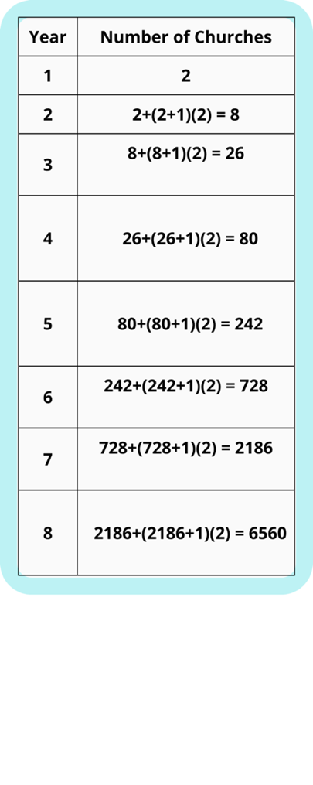**Scenario 2** If instead you only plant two churches per year, but each of those churches is trained to also go out and plant two churches per year, how long would it take to plant 5000 churches?

This calculation is a bit more complicated, but you can see it on the right. In less than eight years, you could see well over 5000 churches planted! This is what we call a reproducing movement of churches, or a church-planting movement.

**中文Key point:**

Small changes in the way we make disciples and equip local believers makes a massive impact on whether we reach our people group or not.

# Reproduction

It is important to understand what reproduction means. Reproduction is also sometimes called multiplication, but multiplication here does not just mean one really gifted person sharing with or discipling many other people (see Figure A).

Reproduction is generational multiplication, one missionary’s influence spreading far beyond what he or she can personally do (see Figure B).

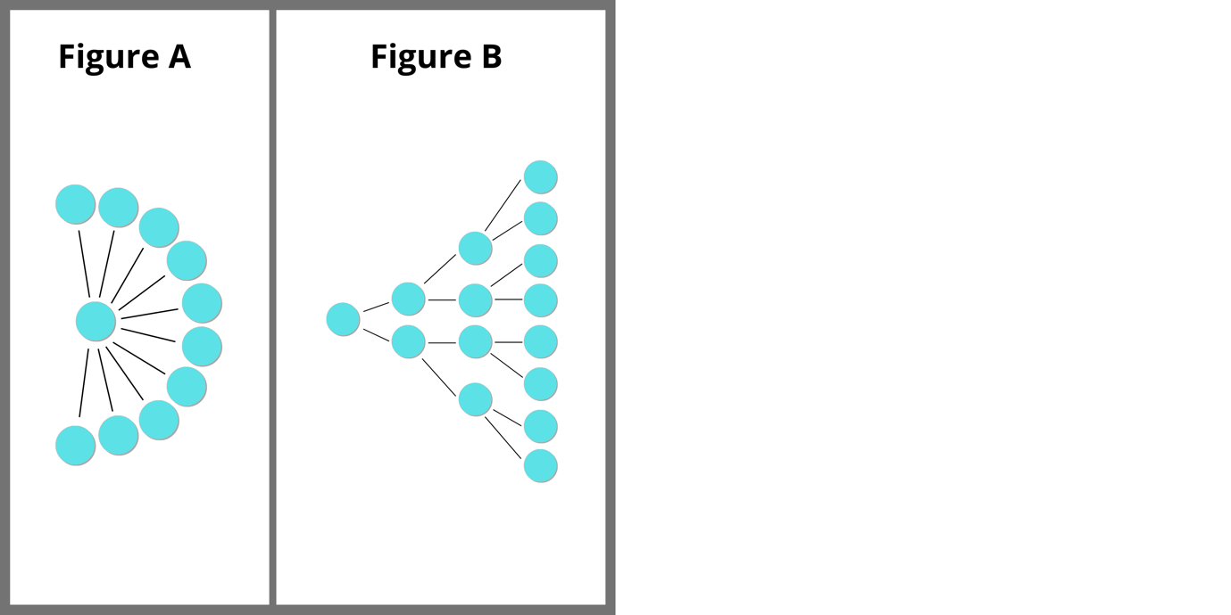

*Figure A represents a model of church planting by addition. Figure B shows the power of multiplication 1 church plants 2 daughter churches that reproduce.*

When we talk about reproduction,, we usually use the 4th generation as a standard. If what we are doing can be repeated by a trained individual or group to the 4th generation without a significant decrease in quality, then it is reproducible.

Why the 4th generation? Part of the answer is simply that, practically, we can have little to no direct influence when things are four generations removed. If what we taught and modeled is continuing to be passed on, it’s not because of our direct presence. The other part is the Biblical model given to us in 2 Timothy 2:2:

…and what you have heard from me in the presence of many witnesses entrust to faithful men who will be able to teach others also. [ESV]

Notice the four generations of reproducing: Paul → Timothy → faithful men → others.

# Traditional vs. Reproducible Church models

For a church to be able to efficiently reproduce to multiple generations, traditional styles of church found in many Western and Han Chinese contexts may not be effective.

Most of us come from a background of a traditional church. That is, very few of us have experience of being part of a church planting movement. Our home churches may have planted one or more daughter churches, but this process of reproduction usually takes years, and churches tend to grow slowly and eventually grow very large (“elephant” churches).

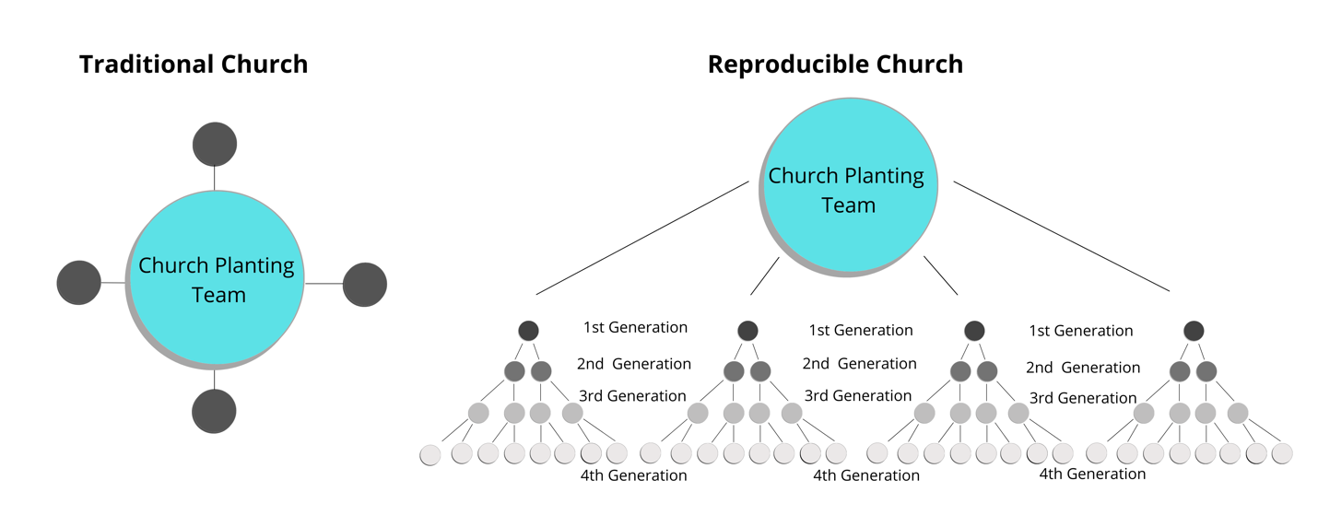

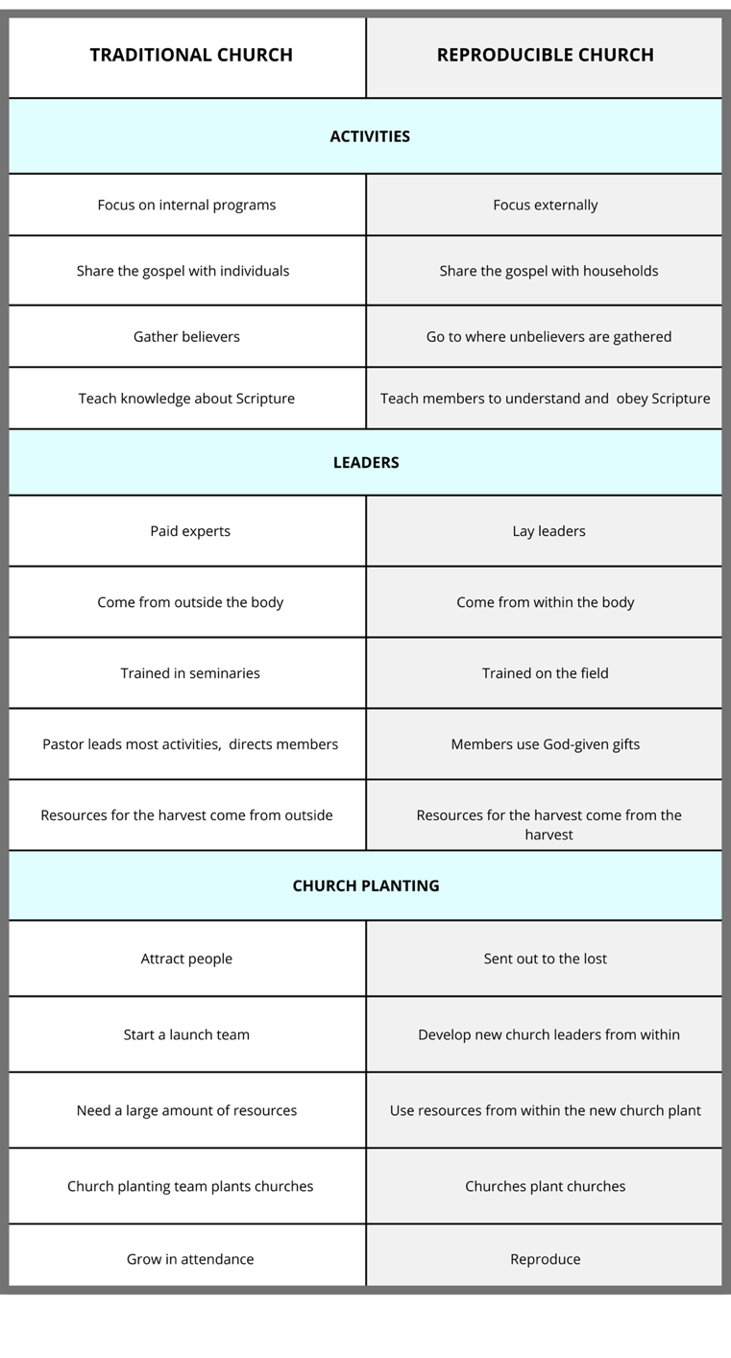

中文Below

|  |  |
| --- | --- |
| **Traditional Church** | **Reproducible Church** |
| Activities | |
| Focus internally | Focus externally |
| Share the gospel with individuals | Share the gospel with households |
| Gather believers | Go to where unbelievers are gathered |
| Teach knowledge about Scripture | Teach members to obey Scripture |
| Leaders | |
| Paid experts | Lay leaders |
| Come from outside the body | Come from within the body |
| Trained in seminaries | Trained on the field |
| Pastor leads most activities & directs members | Members use God-given gifts |
| Resources for the harvest come from outside | Resources for the harvest come from the harvest |
| Church planting | |
| Attract people | Sent out to the lost |
| Start a launch team | Develop new church leaders from within |
| Need a large amount of resources | Use resources from within the new church plant |
| Church planting team plants churches | Churches plant churches |
| Grow in attendance | Reproduce |

This comparison is not meant to cast traditional churches in a negative light or to make us critical of our sending churches. Rather, it is to point out that in most contexts reproducible churches are much more suited to starting church planting movements and thus much more likely to be effective in the evangelization of unreached people groups. By principle, movements are decentralized and difficult to control, but that is exactly what gives them their explosive power to transform entire populations for Christ.

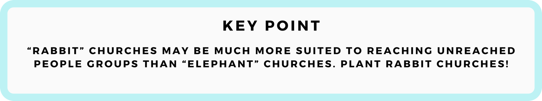

**中文Key Point:**

中文“Rabbit” churches may be much more suited to reaching unreached people groups than “elephant” churches. Plant rabbit churches!

# Rapid Reproduction

What does it mean for church planting to be” rapid”? Do we have any examples of successful churches that were started in a short amount of time? Consider the church planted by Paul and Silas in Thessalonica.

Read Acts 17:1-10

How long were the church planters [Paul and Silas] present in Thessalonica?

Read 1 Thessalonians 3:1-7

After Paul and Silas left, what outside input did the Thessalonians receive?

Read 1 Thessalonians 1:6-10

Did the Thessalonians do anything to share their faith? Were they effective?

Read 1 Thessalonians 4:1,9-10

Did the Thessalonian church seem to be lacking anything major? Do they seem healthy?

Despite only spending about three weeks with a “church planting team” and then receiving occasional visits and letters, the church in Thessalonica seems not only to have a sound grasp on doctrine, walking with Christ, and brotherly love but also to have had a significant role in multiplying throughout and beyond their province! All this through three weeks of hard work!

Why? Paul and Silas trained them well, empowered them, and remained in contact with them. Remember, church planting movements typically have rapid reproduction. However, this is not due to an emphasis on speed, but rather due to an emphasis on immediacy in discipleship – new believers are taught to immediately apply what they learn and to share their faith with others – as well as intentional empowerment of local believers by those who are training them.

# A DNA for Reproducibility

Churches can multiply to the fourth generation and beyond if they are “wired” with a DNA for reproducing. Namely, we can help churches to:

* Develop a vision for church planting
* Use reproducible, easily imitated methods for evangelism, discipleship, and church planting
* Accept their responsibility to plant churches

A reproducing church is a place where every member is trained to be a church planter. Therefore, every church is actually a church planting training center!



**中文Key point:**

中文We can help churches have a DNA to reproduce from the beginning.

# Discussion: Two Models of Church Planting

Based on these models and the discussion above, divide into groups of 3-4 and discuss the following question.

What are some of the key differences between traditional church planting and reproducible church planting?